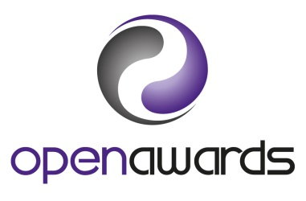 

**OPEN AWARDS LEVEL 3 - PORTAGE PRACTICE**

**Registered Office: Kings Court, 17 School Road, Hall Green, Birmingham B28 8JG**

Personal Information

|  |  |  |  |
| --- | --- | --- | --- |
| Surname Name: | | | Given Name: |
| Date of Birth: | | | NPA Membership Number: |
| Personal address:  [It is important to give your personal details as we may need to contact you at times other than when you are working. |  | | |
| Postcode: |  | | |
| Personal Telephone: | | Personal Email: | |
| Mobile: | | Work Email: | |
| Work Telephone: | |  | |
| Working Pattern: Full time/Part time | | Nationality: | |

Billing Details – Invoice for £500 to be submitted to:

|  |  |
| --- | --- |
| Name: |  |
| Address: |  |
| Email: |  |
| Telephone: |  |

Experience and Qualifications

|  |
| --- |
| My current involvement with early years/SEND children is: |

|  |  |  |
| --- | --- | --- |
| GCSE Qualifications | Year | School or College |
|  |  |  |
|  |  |  |
|  |  |  |
|  |  |  |
|  |  |  |

 

NPA Portage Workshop Details

|  |  |
| --- | --- |
| Date NPA Portage Workshop Attended: |  |
| NPA Portage Workshop Certificate number: |  |
| Name(s) of NPA Accredited Trainer(s) who delivered the NPA Portage Workshop  1.  2. | |

Mentor Details (Your Mentor may be an Accredited Trainer who delivered the NPA Portage Workshop you attended or your team leader or supervisor)

|  |
| --- |
| Name of Mentor:  Address of Mentor:  Contact email: |

|  |
| --- |
| I wish to register through the National Portage Association (NPA) as a student on the Open Awards Level 3 - Portage Practice.  I am submitting a signed Mentor and Learner Agreement with this application.  I will maintain my individual NPA membership whilst completing this qualification.  I agree to pay/arrange payment of the fee of £500 (VAT is not charge) on receipt of an invoice from the NPA.  Signed: ________________________________________________ Date:_____________________________  (Student) |

|  |  |
| --- | --- |
| For NPA office use only: | |
| Invoice number: | Invoice date: |
| Date invoice paid: | Date enrolled with Open Awards: |
| Date of access to portfolio materials for Student and Mentor: | |
| Date enrolment confirmed to Student and Mentor: | |