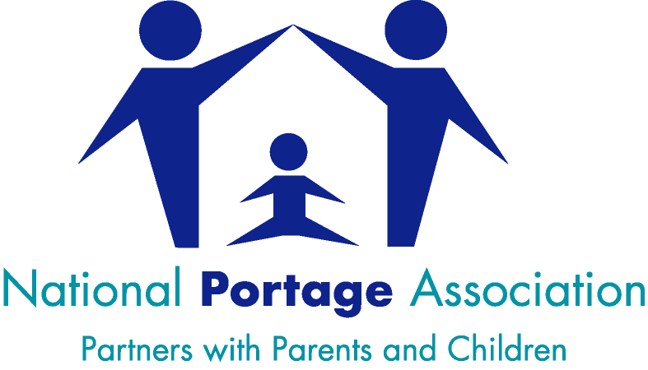

CRITERIA FOR SERVICE REGISTRATION 2024-2025

The criteria are reviewed annually

Grading System
NPA Registered Portage Service – 5 star ***** | Meets all ‘essential’ criteria and one ‘desirable’
NPA Registered Portage Service – 4 star **** | Meets all ‘essential’ criteria, with supporting information if less frequent home visits are available. Service provisions will be reviewed by the NPA on an individual basis.
NPA Registered Portage Service - Establishing | New Services will be allocated a Mentor from the NPA Board of Trustees, to assist with establishing their Service in line with the NPA Code of Practice. They will remain on this grading for 2 years, after which time they will be assessed for the next appropriate grading level.
Early Years’ Service (NPA Affiliated) | Service who meets all ‘essential’ criteria APART FROM the home visiting criteria
Essential Criteria

Is there evidence that Portage Principles underpin their early years practice?
Does the Service provide home visiting ?
Is the home visiting weekly/fortnightly ?
If anything other than weekly/fortnightly home visiting is ticked, the Service can ONLY be granted AFFILIATED status (other essential criteria still needs to be achieved)
Is there evidence of other activities taking place to support/complement the home visits?
Is there evidence of holistic assessment taking place, including the use of a broad range of materials (including observational records and developmental profiles/checklists)?
Is regular supervision taking place?
Is the person providing the supervision an experienced early years professional with a good understanding of Portage?
Is there a formal appraisal system in place to support development?
Do the number of nominated Members meet the required criteria for the size of the Service?
The minimum requirement here is for 3 members unless they are a small Service with 4 (fte) practitioners or less, in which case 50% of the team must hold professional membership of the National Portage Association
Have all Home Visitors/Early Years Practitioners successfully completed a Portage Workshop delivered by a trainer accredited by the National Portage Association and are there plans in place for the training of new staff?
Desirable Criteria

Is there an NPA Accredited Trainer within working within the service?
Are there at least 3 members of the team who have successfully completed the NPA ‘Core Competencies?’ (Or for a small team with 4 (fte) practitioners or less, we are looking for 50% of their team to have completed this)
Are there at least 3 members of the team who hold an NPA recognised advanced level qualification in Portage? (Or for a small team with 4 (fte) practitioners or less, we are looking for 50% of their team to hold one)
The NPA recognised advanced level qualifications in Portage are as follows: -
- Level 3 Open Award in Portage
- BTEC level 3 in Portage Skills
- BTEC Level 4 in Portage Practice
- relevant degree/BTEC Level 4 equivalent qualification

