**Use of the Association’s Logo by Third Parties on Stationery**

Article 27.5 of the Association’s Articles of Association allows Registered Portage Services to use the Company’s logo. The Trustee Board also extends this right to NPA Accredited Trainers. The information below explains under what circumstances the logo can be used, and the restrictions that apply, as approved by the Trustee Board on the 23rd November 2001.

The logo is the property of the National Portage Association, and a registered trademark. Portage Services registered with the Association and Trainers accredited by the Association may use the logo on their letterheads/literature subject to the following conditions.

1. The logo cannot be used in place of your own logo

1. If you cease to be a Registered Service or Accredited Trainer, you must stop using the logo from the date on which you ceased being registered/accredited, destroying any unused stationary carrying the logo.
2. The logo must be accompanied by one of the following statements
   1. A Portage Service registered with the National Portage Association.
   2. An Accredited Trainer with the National Portage Association.
3. The logo should be positioned at the bottom of your stationery.
4. The size of the logo is limited to the three examples below.

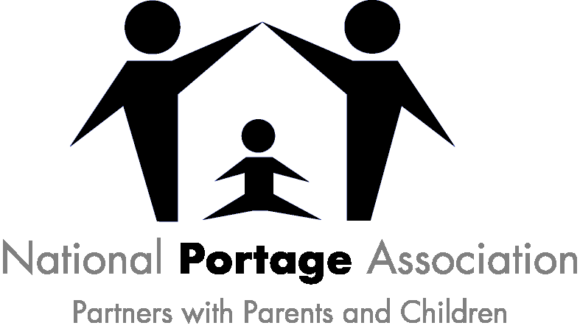 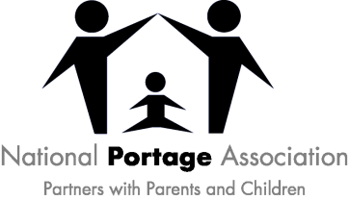 

1. The logo should be printed in the colours listed below or in Black and Grey.

Colours: Dark Blue pantone 072cv

Light Blue pantone 2915c

Under no circumstances should the logo be used by any other third party or in any other capacity. The Association will not hesitate to take action against anyone whom it believes is using its logo without its permission or is in breach of these conditions. Proofs should be sent to the NPA Office or e-mailed to administrator@portage.org.uk for approval prior to printing.

**Use of the Association’s Logo by Third Parties on Clothing**

The Trustee Board agreed on 25 November 2016 to allow Registered Services and Individual Fundraisers supporting Portage the right to use the NPA logo on clothing.

The logo is the property of the National Portage Association, and a registered trademark. Portage Services registered with the Association and Individual Fundraisers may use the logo on their clothing subject to the following conditions.

1. The complete logo must be used - it should not be used in part.
2. If you cease to be a Registered Service you must stop using the logo from the date on which you ceased being registered and destroy any clothing carrying the logo.
3. The size and positioning of the logo is not stipulated but should be proportionate to its use.
4. The logo should be printed using the colours combinations listed below.

* Dark Blue pantone 072cv and Light Blue pantone 2915c
* Entirely White on a coloured background
* Black and Grey

Under no circumstances should the logo be used by any other third party or in any other capacity. The Association will not hesitate to take action against anyone whom it believes is using its logo without its permission or is in breach of these conditions. Design proofs should be sent to the NPA Office or e-mailed to administrator@portage.org.uk for approval prior to printing.